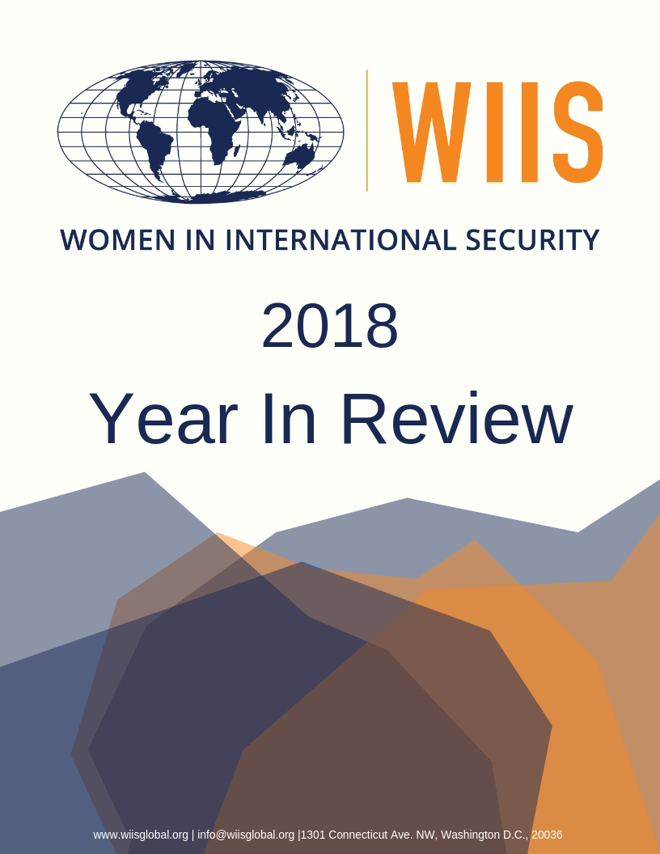
The Year in Review: 2018

From the beginning, the core mission of Women In International Security (WIIS) has been to advance the professional development and leadership of women in the field of national and international security. WIIS continued to advance this mission in 2018 by supporting young women entering the field and by promoting women experts in the United States and around the globe.

WIIS also continued to expand its research and policy engagement initiatives on critical global security issues, including the nexus between gender and security, through policy roundtables and the publication of policy briefs.

In addition, WIIS developed partnerships with other institutions in the U.S. and abroad. WIIS also maintained its status as the financial agent for the U.S. Civil Society Working Group on Women, Peace and Security (US CSWG)

WIIS hosted and co-hosted over twenty events. Furthermore, WIIS Fellows participated in numerous conferences in the US and around the world. Highlights included invitations to take part in the Paris Peace Forum on October 11-13, 2018 and the Nobel Peace Prize Ceremony in Oslo on December 10, 2018. WIIS President, Chantal de Jonge Oudraat, was also invited to give a keynote address at the Women in National Security Conference organized by the National Security College, ANU, in Canberra, Australia on October 24-25, 2018.

In 2018, WIIS published 18 policy briefs and blogs. Additionally, Dr. de Jonge Oudraat contributed a Chapter to the 2019 Oxford Handbook on the Women, Peace and Security Agenda. Ellen Haring, Senior Fellow and Director of the CII Initiative, published work in the Army Times.

WIIS’ presence on social media continues to grow. In 2018, WIIS had over 9,000 page likes on Facebook and our posts reached more than 41,000 people. Since June 2018, the WIIS Instagram gained over 100 followers. In addition, WIIS continues to tweet and share news with close to 5,000 followers on Twitter.

In 2018, WIIS also updated its logo and website. The new website includes a user-friendly interface for members only. WIIS encourages its members to fill out their profiles on the member-only part of the website. Complete profiles will broaden and strengthen the WIIS network by increasing content in the member database and helping WIIS HQ direct media demands. With your help, we can build a vibrant community where members can start online forums, contact each other directly for networking and mentorship opportunities in their area, and connect with other members around the globe when traveling.

All in, 2018 was another very successful year in which WIIS expanded its network and activities. WIIS could not have done this without you and the whole WIIS team thanks you for your continuing support!

WIIS PROGRAMS

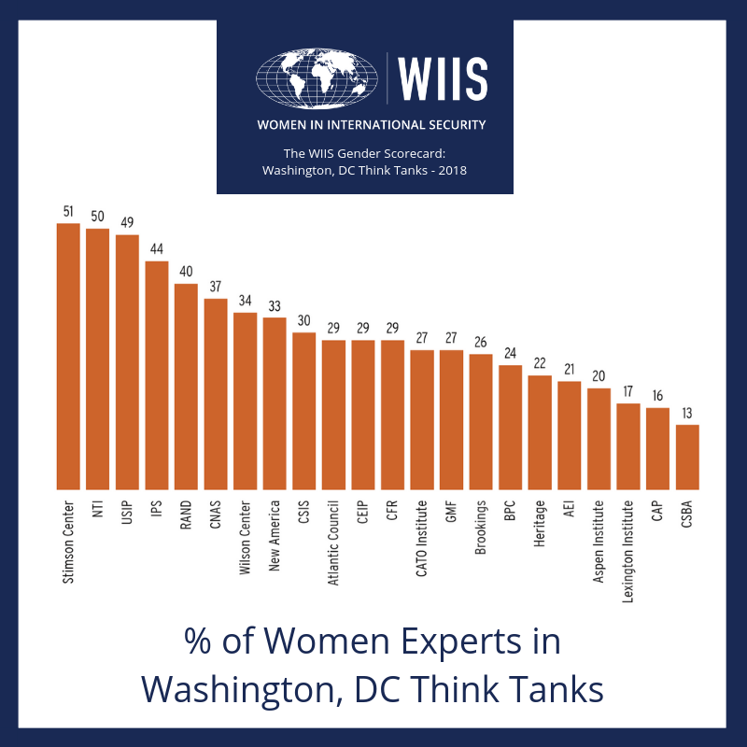
The Gender Scorecard Initiative
The Gender Scorecard Initiative is an on-going WIIS program. Through this initiative, WIIS measures and assesses how well institutions and programs mainstream gender.

On September 24, 2018, WIIS released the WIIS Gender Scorecard: Washington, DC Think Tanks 2018.

The scorecard reviewed 22 major Washington, DC think tanks working on foreign policy and national and international security issues along four main axes:
(1) percentage of women leading think tanks;
(2) percentage of women experts;
(3) percentage of women in governing bodies;
(4) percentage of think tanks with significant commitment to gender and/or women’s programming.

The scorecard showed significant gender gaps at the leadership, expert, and governing board levels of Washington, DC think tanks.

In response to the findings of the think tank scorecard, WIIS will launch The Blue Book: A Roster of Women Experts ready to serve on governing boards of think tanks and other NGOs. This resource will go live in early 2019. Members will be able to apply through the WIIS website.

The GPS Initiative
The Gender, Peace, and Security (GPS) Initiative was launched in 2017 and is designed to examine the gender dimensions of national and international security challenges. This venture furthermore seeks to and bridge existing divides between the traditional security community and the Women, Peace and Security community.

Under this initiative, WIIS launched the Next Generation Symposium in 2017. The 2017 Next Generation Fellows published several policy briefs and blogs in 2018. The Next Generation Symposium will reprise in 2019.

The book project launched under the GPS initiative examines the gender dimensions of important international security challenges. WIIS convened the second author workshop on April 16-17, 2018, in Washington, DC. The book brings together authors from across the world, genders, and disciplines.

Authors include: Edward Carr, Professor and Director of the International Development, Community, and Environment Department, Clark University, Sara Davies, Associate Professor and ARC Future

Fellow, Griffith University; Jane Freedman, Professor, University of Paris 8; Anne-Marie Goetz, Center for Global Affairs at New York University; Ellen Haring, Senior Fellow, Women In International Security; Rob Jenkins, Professor Department of Political Science, Hunter College; Jeanette Gaudry Haynie, Senior Fellow, Women In International Security; Jeni Klugman, Managing Director of the Georgetown Institute on Women, Peace and Security; Sari Kouvo, Senior Lecturer, University of Gothenburg; Kathleen Kuehnast, Director of Gender Policy and Strategy, United States Institute of Peace; Corey Levine, Human Rights Humanitarian Law Policy Expert; Tamara Nair, Research Fellow at Centre for Non-Traditional Security Studies, S. Rajaratnam School of International Studies (RSIS) at Nanyang Technological University; and Jacqui True, Professor and Director at Monash Gender Peace and Security Centre, Monash University.

WIIS President, Chantal de Jonge Oudraat and Michael E. Brown, Professor of International Affairs and Political Science at the George Washington University Elliott School of International Affairs, are the editors of the book.

The April workshop benefited from the expertise and comments of Professors J. Anne Tickner, Emerita Professor in the School of International relations at the University of Southern California and Distinguished Scholar in Residence at the School of International Service at American University; Paul D. Williams, Professor at the GWU Elliott School of International Affairs, of International Affairs and Virginia Haufler, Professor of Political Science at the University of Maryland; Christopher Kojm, Professor of International Affairs ate the GWU Elliott School of International Affairs and former Chairman of the National Intelligence Council; and Mona Lena Krook, Professor of Political Science at Rutgers University.

The Gender, Peace and Security Roundtable Series

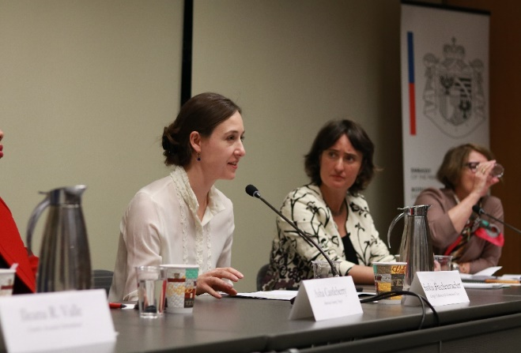
With the generous support of the Embassy of Liechtenstein in Washington, DC, WIIS facilitates a series of expert roundtables to explore the gender dimensions of critical security challenges. These roundtables bring together a diverse group of experts and policymakers to advance gender considerations in security policy deliberations.
Panelist Saskia Brechenmacher, Associate Fellow at the Carnegie Endowment for International Peace speaks at the Women In Politics Roundtable

In March, WIIS was honored by the presence of the Foreign Minister of Liechtenstein, H.E. Aurelia Frick.

WIIS and the Embassy of Liechtenstein hosted four policy roundtables in 2018:

- People on the Move: The Gender Dimensions of Migration, Refugee Crises, and Human Trafficking, Washington, DC - March 2018
- Climate Change: The Gender Dimensions, Washington, DC - April 2018
- Youth, Peace and Security, Washington, DC - June 2018

- Women In Politics, Washington, DC - November, 2018

More information about the roundtables are available on the past events page on the WIIS website.

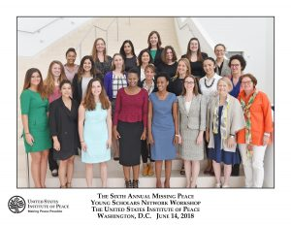
The Missing Peace Initiative
Created in 2013, the Missing Peace Initiative is a project of the United States Institute of Peace (USIP); the Human Rights Center at the University of California, Berkeley; the Peace Research Institute Oslo (PRIO); and WIIS. This project brings together expert scholars, policymakers, practitioners, and military and civil society actors to examine the issue of sexual violence in conflict and post-conflict settings, identify gaps in knowledge and reporting and explore how to increase the effectiveness of current responses to such violence.

The Missing Peace Young Scholar Network is part of the Missing Peace Initiative and brings together a global community of young scholars examining issues related to sexual violence.

With the above partners, WIIS convened the sixth annual Missing Peace Young Scholar Workshop in Washington, DC from June 14-15, 2018. The theme was Ten Years Since UNSCR 1820: Translating Scholarship into Policy for the Prevention of Sexual Violence.
Find the Program here.

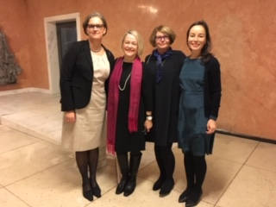
Members of the 6th Young Scholar Network Symposium authored “The Elusive Peace: Ending Sexual Violence during and after Conflict” (December, 2018). Additionally, Alicia Luedke, a member of the Young Scholar Network, contributed a blog on sexual violence in South Sudan.
Missing Peace founders: Inger Skjelsbaek, University of Oslo and PRIO, Kathleen Kuehnast, USIP, Chantal De Jonge Oudraat, WIIS, Kim Thuy Seelinger, UC Berkeley-Human Rights Center at the Nobel Peace Prize Ceremony in Oslo, Norway

In December, the founders of the Missing Peace Initiative met in Oslo at the occasion of the 2018 Nobel Peace Prize Ceremony. The Nobel Peace Prize Ceremony recognized Nobel Peace Laureates Nadia Murad and Denis Mukweged for their contributions to ending sexual violence as a weapon of war.

The Combat Integration Initiative (CII)
To support the successful integration of women into the newly opened combat positions women in the armed forces, WIIS established the Combat Integration Initiative (CII) in 2013. The CII examines and monitors the integration of women into the military, focusing on five activities deemed necessary for effective implementation. These five areas include (1) Transparency of the implementation process;( 2)

Communication of policy changes; (3) Establishing gender-neutral occupational standards; (4) Providing training to leaders addressing military culture, and (5) Mentoring/Gender Advising.

Dr. Ellen Haring, Director of the CII Initiative and Senior Fellow, Professor Megan MacKenzie of the University of Sydney, and Ms. Antonieta Rico WIIS Fellow and Communications of the Service Women Action Network (SWAN), have continued research on the status of women’s integration in combat positions. The team conducted a total of seventeen interviews and two informal focus group discussions in the U.S. and Europe.

On March 24, 2018, Dr. Haring and Ms. Rico facilitated a day long workshop in Killeen, Texas. The Trailblazers workshop provided infantry and armor women tools for successfully integrating into combat arms units.

Professor Mackenzie published “Will Letting Women Fight Fix Gender Inequality?” in Foreign Affairs (April 2018). Professor Mackenzie argues that enforcing gender equality “is not a silver bullet for reducing sexual violence, increasing the number of female leaders, or enhancing combat capacity for the U.S. military.” Using the interviews and focus groups as her evidence, she advocates for institutional change to fully implement the integration of women in combat service roles. Lastly, she recommends that institutions listen to women to promote authentic gender equality.

Dr. Haring published ‘Leaders First’ is a Failed Policy in the Army Times (August2017). Dr. Haring argues that the “Leaders First” initiative presents a barrier to women who want to enter combat arms and causes male soldiers to be resentful of these women. She recommends that policy makers abandon the approach.

The Women, Peace and Security Leadership Training Program
Dr. Ellen Haring and Dr. Chantal de Jonge Oudraat conducted a week-long gender audit training for United Arab Emirates government officials and business leaders in Dubai (UAE) in October 8-12, 2018. The training took place in partnership with TRENDS Training.

The Mentoring and Professional Development Program
The Mentoring and Professional Development Program increases the professional opportunities of women. The program helps women navigate real and presumed obstacles in their careers through the provision of a skill-building series, resource center, and promotion of a transparent network of leaders. The program also organizes networking happy hours and other bonding activities for women to expand and solidify their networks in international security.

In 2018, the Program organized five events to connect and promote women in international security.

In June 2018, WIIS and the Women’s Foreign Policy Group (WFPG) signed a partnership agreement to collaborate on professional development and mentorship programs. As part of the new partnership

WIIS and the WFPG hosted on August 8 an event entitled “Taking the Next Step to Leadership: Advancing Your Career in International Security.” The event mixed traditional mentoring formats with an informal networking hour, a structured panel, and two intimate break-out sessions with the six panelists. The panelists ranged from mid-level to senior level positions in the public and private sector.

Other events, initiatives AND Partnerships

- Diverse Boots on the Ground: EU and NATO Effectiveness,
Washington, DC –December 10, 2018

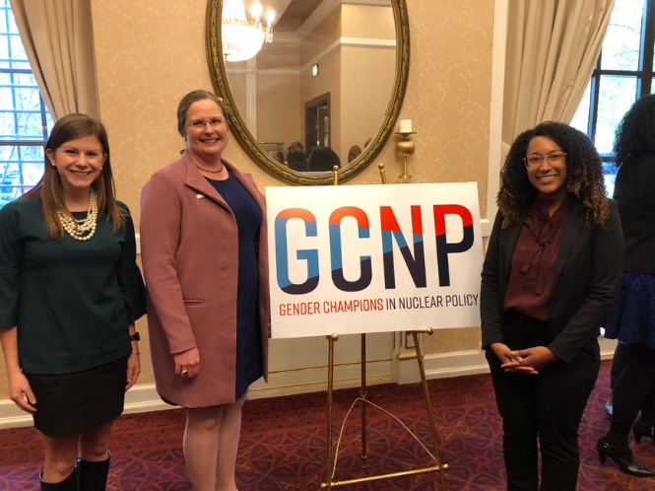
Dr. Ellen Haring served as a panelist for an event titled Diverse Boots on the Ground: EU and NATO Effectiveness on December 10, 2018. This event was sponsored by the Wilson Center’s Women in Public Service Project (WPSP), the German Marshall Fund (GMF) and WIIS. The event presented “Raising EU and NATO Effectiveness: The Impact of Diverse Boots on the Ground” by Corinna Horst (WIIS Brussels President), Laura Groenendaal, and Professor Gale A. Mattox (former WIIS Global President).
Program Assistant Sarah Kenny and Senior Program Assistant Nadia Crevecoeur pose with former WIIS President, Ambassador Laura Holgate

- Gender Champions in Nuclear Policy, Washington, DC – November 14, 2018

Dr. Chantal de Jonge Oudraat, was honored as a Gender Champion at The Future of US Nuclear Policy: National Security & Nuclear Policy Briefings annual conference on November 14. At the event- which marked the launch of the Gender Champions in Nuclear Policy initiative- more than twenty-five leaders were recognized for their commitments towards gender equality. The Champions all signed the Panel Pledge, in which they promised to avoid sitting on single-gender panels. Furthermore, the champions made three personal pledges to achieve gender parity within their organizations. See the pledges that Dr. de Jonge Oudraat made here.
- Paris Peace Forum, Paris, France – November 11-13, 2018

WIIS was invited to participate in the first Paris Peace Forum from November 11-13th, 2018 in Paris, France. WIIS President, Dr. Chantal de Jonge Oudraat, represented WIIS as an internationally recognized non-profit working on gender related peace and security issues.
Fauziya Abdi Ali, President of WIIS Horn of Africa, was selected as a member of the Steering Committee, which chose the 120 projects that were represented at the Paris Peace Forum.

- WIIS and CERBERUS Consulting – November 1, 2018

On November 1, 2018, WIIS joined forces with CERBERUS Consulting and the Open Gov Hub to host an event on Election Integrity in the Digital Age: Election Cybersecurity Challenges in the US and Around the World.

- Women In National Security Conference, Canberra, Australia – October 24-25, 2018

Dr. Chantal de Jonge Oudraat was invited to deliver a keynote address at the Women In National Security Conference organized by the National Security College, ANU, Canberra, Australia, (October 24-25, 2018).

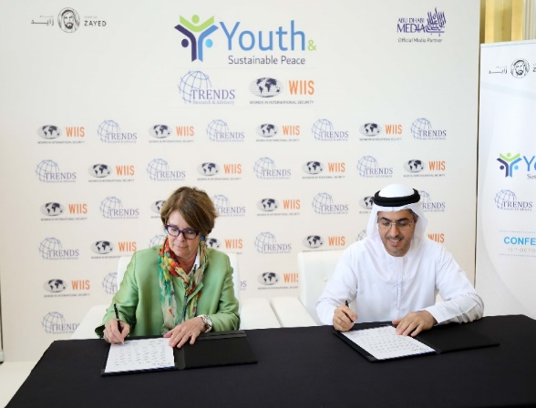
- WIIS and TRENDS Research & Advisory – October 25, 2018
Dr. Chantal de Jonge Oudraat and Dr. Ahmed Al Hamli extend WIIS and TRENDS Research & Advisory’s Partnership

As part of their partnership agreement, WIIS and TRENDS Research & Advisory organized a global conference on “Youth and Sustainable Peace” in Abu Dhabi (UAE) on October 15, 2018

- The Gender Gap in 2018: Supporting Women in the International Security Community, Washington, DC – September 24, 2018

In partnership with the Nuclear Threat Initiative (NTI), Women In Defense (WID), Women's Foreign Policy Group (WFPG), Women's Foreign Policy Network (WFPN), WIIS Global, and WIIS-DC hosted The Gender Gap in 2018: Supporting Women in the International Security Community on September 24, 2018. The five-member panel event focused on the status of the gender gap in the international security field and best practices to support women’s leadership in the field.
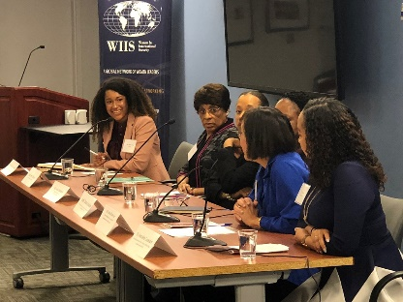
Senior Program Assistant Nadia Crevecoeur moderates a Conversation with Women of Color Advancing Peace and Security on March 26, 2018
- A Conversation with Women of Color Advancing Peace and Security, Washington, DC – March 26, 2018

WIIS Global, WIIS GWU, and Women of Color Advancing Peace and Security (WCAPS) co-sponsored a conversation with distinguished women of color in the international security field about the importance of greater diversity and how to bring this about.

- U.S. Foreign Policy in the 21st Century International Security Conference, Idaho State University, Pocatello, Idaho – March 1-2, 2018

Dr. Chantal de Jonge Oudraat gave the keynote address at the U.S. Foreign Policy in the 21st Century International Security Conference sponsored by the Idaho State University International Affairs Council on March 1, 2018.

- Enhancing Women’s Roles in International Countering Violent Extremism Efforts,
Madrid, Spain – March 19-21, 2018

Dr. Chantal de Jonge Oudraat also provided remarks at a Hedayah and the Madrid-based Foundation for the Analysis and Social Studies (FAES) workshop on the roles of women in international efforts to prevent and counter violent extremism.

- U.S. Civil Society Working Group on Women, Peace and Security

The U.S. Civil Society Working Group on Women, Peace, and Security (CSWG) is a network of experts, NGOs, and academics with years of experience working on issues involving women, war, and peace. Inspired by and building on the international WPS agenda, the CSWG informs, promotes, facilitates, and monitors the meaningful implementation of the U.S. National Action Plan on WPS and the WPS Act adopted by the U.S. Congress in October 2017. WIIS is a member of the Group’s Executive Committee and fiscal agent of the group. For more on the U.S. CSWG, click here.

WIIS Chapters and Affiliates
WIIS has members in 47 countries and on six continents. WIIS members work in international organizations, government, NGOs, think tanks, universities, corporations, and media outlets around the world. Currently, WIIS has a network of ten U.S. chapters and twenty-six international affiliates. The WIIS Global Network keeps in touch through a monthly Global Call.

In 2018, WIIS introduced new affiliates in Port-au-Prince Haiti, and Paris, France. WIIS also re-introduced U.S. chapters at the Middlebury Institute and the University of Notre Dame.

Highlights from the WIIS Global Network:

- WIIS Australia
After a brief hiatus, WIIS Australia resumed activity under Dr. Elizabeth Buchanan in October 2018.

In Sydney, Dr. de Jonge Oudraat presented on WIIS’ work to advance the roles of women in international security. On October 26, she participated in a WIIS-Australia panel co-hosted by Professor Bates Gill of Macquirie University. The panel also featured Susan Harris Rimmer, Associate Professor of Griffith University and Sue Thompson, Senior Lecturer at the National Security College,
the Australian National University. The women shared their experiences in the international security field.

- WIIS Austria
WIIS Austria President, Jessica Grün, hosted close to ten events, including several networking and professional development events, as well substantive policy roundtables.

Notable events:
- Migration and Integration in Germany and Austria, Vienna, Austria - December 10, 2018
- Sexual Violence in Conflict with Justice Winter, Vienna, Austria - November 28, 2018

- WIIS Brussels
For two decades, WIIS Brussels has promoted leadership training, mentoring, and networking activities on current policy challenges. WIIS Brussels benefits from the presence of the EU institutions and NATO as well as a very high concentration of diplomatic representations, international organizations and other influential stakeholders, putting it at the center of key policy discussions on international relations, security and defense.

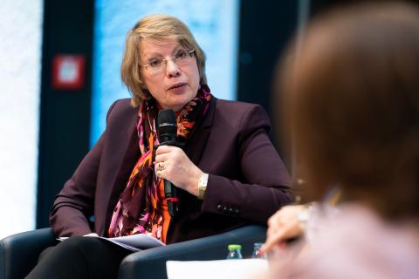
Under the leadership of Corinna Horst, WIIS Brussels hosted numerous events including policy debates on critical topics in international security, mentoring, and professional development programs. Most notably, WIIS Brussels helped organize NATO Engages: The Brussels Summit Dialogue in July 2018.
Dr. Armgard Von Reden at the 15-year anniversary conference Photograph taken by Henning Schacht

- WIIS Germany – (WIIS.de)
In late 2017, Dr. Armgard Von Reden was elected as the new Chairwoman of WIIS.de after the tragic passing of Dr. Sylke Tempel. Dr. Tempel was honored at the Munich Security Conference in February 2018 as well as at the 15th anniversary conference.

WIIS.de celebrated its fifteenth anniversary with a high-level international conference entitled Is The Future Democratic? Democracy, Security, Technology.

- WIIS Canada
In 2018, Caroline LePrince was elected as the Executive Director of WIIS Canada. Ms. LePrince previously served on the Board of WIIS-Canada and co-organized the 2017 WIIS Canada Annual Workshop and Tenth Anniversary of WIIS Canada.

In 2018, WIIS Canada increased its membership base across the country and held stimulating events on peace and security. WIIS Canada will hold its 12th Annual Workshop in Toronto, Ontario in the late spring of 2019.

Notable Events:

- Leading from the Front: Combating Gender-Based Violence in the Canadian Armed Forces, Ottawa, Canada, December 5, 2018
- End Gender-Based Violence in the World of Work, Canada, November 25-December 10
- The Gender Perspective in Policy and Operations, Montreal, Canada, November 15, 2018
- WIIS Canada’s 11th Annual Workshop: Gender & Security, from the Bottom-Up, University of Alberta, Canada, May 2- 4, 2018
- International Security in 2018: Canadian Responses to Contemporary Challenges, Toronto, Canada, April 24, 2018
- The Canadian Armed Forces: Women and Leadership, Kingston, Canada, January 15, 2018

- WIIS France
Under the leadership of Johanna Moehring, WIIS France was created during the spring of 2018.. WIIS France is committed to building a community of experts from all generations and with diverse experiences to promote the representation of women in the field of security and defense in France. WIIS France organized a panel entitled Women, Actresses of Peace? at the AEGES Conference in Lille France on December 6-7 2018. An official launch event for WIIS France is planned for February 2019.

- WIIS Italy
WIIS Italy was created in April 2016 and is managed by a group of volunteers who have set out to promote the mission of WIIS through events, debates and seminars on issues related to women and international peace and security. WIIS President Irene Fellin is also spearheading the Women Mediators Network in the Mediterranean, a project funded by the Italian Foreign Ministry.

- WIIS India (WISCOMP)
Established in 1999, WISCOMP has been a pioneer in initiating the discourse on women, peace, and security in South Asia. This affiliate was at the forefront of engaging with these issues well before they were articulated in UN Security Council Resolution 1325 in October 2000. WISCOMP is an initiative of the Foundation for Universal Responsibility, which was established with funds from the Nobel Peace Prize awarded to His Holiness The Dalai Lama in 1989.

WISCOMP draws on innovative and experiential pedagogies that synergize research, training, and practice. They use these pedagogies to build linkages between individuals who work in the fields of education, gender studies, peacebuilding, public policy, law, and the creative arts.

In 2018, WIISCOMP conducted close to twenty workshops, trainings, and policy events. The affiliate also published “(Re)Storying Kashmir: Exploring possibilities for Constructive Partnerships” by Meenakshi Gopinath, Seema Kakran and Shilpi Shabdit.

- WIIS Poland
WIIS Poland was established in November during the 2017 Warsaw Security Forum. WIIS Poland is housed within the Casimir Pulaski Foundation, an independent and a-political think tank that focuses on issues across foreign policy and international security. WIIS Poland hosted a networking breakfast for women in international security at the 2018 Warsaw Security Forum.

- WIIS Spain (SWISS)
Dr. Marian Caracuel is the founding Director of SWISS. Dr. Caracuel works at the Counsellor Area of the Cabinet of the General Secretariat for Defense Policy (Ministry of Defense) and is the founder of both the Association of Spanish Graduates in Security and Defense Issues (ADESyD) and SWIIS. SWIIS is housed under the ADESyD. Dr. Caracuel was appointed by an absolute majority of the Senate as a member of the Observatory of Military Life, which is closely linked with the Spanish Parliament. SWISS also participated in the meeting of the NATO Panel on Women, Peace and Security in Brussels October 9-10, 2018.

Notable events:
- Women, Security and Defence: Advancing Together for Peace, Madrid,- November 11, 2018
- Where are the Women? Madrid - February 3, 2018

2018 - WIIS Publications

Policy Briefs and Working Papers

  - Recognizing the Violent Extremist Ideology of ‘Incels’ by Shannon Zimmerman, Luisa Ryan and David Duriesmith, WIIS Policybrief, September 2018.
  - Sexual and Gender Based Violence in Refugee Settings in Kenya and Uganda by Pearl Karuhanga Atuhaire and Grace Ndirangu, WIIS Policybrief, March 2018.
  - Gender Parity in Peace Operations: Opportunities for U.S. Engagement by Luisa Ryan and Shannon Zimmerman, WIIS Policybrief, March 2018.
  - Missing Figures: The Cybersecurity Gender Gap, Working Paper by Spencer Beall, WIIS Working Paper, February 2018.
  - Improving Gender Training in UN Peacekeeping Operations by Velomahanina T. Razakamaharavo, Luisa Ryan, and Leah Sherwood, WIIS Policybrief, February 2018.

WIISBlogs

  - South Sudan: Recent scourge of sexual violence is not new and will continue unless there is justice for survivors by Alicia Luedke, WIISBlog, December 2018.

  - Women and the 2018 US Mid-term Elections: Implications for National Security by John Arnold, Sarah Kenny, Hannah Lynch and Nadia Crevecoeur, WIISBlog, December 2018.
  - Washington Think Tanks: A Man’s World by Nadia Crevecoeur, WIISBlog, November 2018.
  - WIIS Chapter Germany to Celebrate Its 15 Year Anniversary on November 15, 2018 by Karin Johnston, WIISBlog, November 2018.
  - Morocco: The Leader for Women’s Progress in MENA by Betsy Markey, WIISBlog, November 2018.
  - BeecherMadden Finds that Women Now Make Up Eighteen Percent of the Cyber Security Industry by Karla Reffold, WIISBlog, November 2018.
  - In Support of Equity by Sarah Kenny, WIISBlog, November 2018.
  - Stabilizing U.S.- Chinese Relations by Amanda Spencer, WIISBlog, October 2018.
  - Women in Al-Shabaab through a New War’s Lens by Phoebe Donnelly, WIISBlog, July 2018.
  - Why FGM in the US is Rarely Prosecuted by Soraya Kamali-Nafar, WIISBlog, July 2018.
  - We Want to be ‘Returned’ too! Gender and Reintegration of Returnees in Kenya by Margaret Monyani, July 2018.
  - What Gina Haspel’s Confirmation Really Represents by Sahar Khan, WIISBlog June 2018.
  - Understanding the Enemy by Chelsea Costello, WIISBlog, February 2018.

WIIS Jobs Hotline and Events Hotline

The WIIS Jobs Hotline continues to grow. This resource lists job and fellowship opportunities in the national and international peace and security field from employers in the public and private sector in the United States and abroad. The Jobs Hotline is published every other week. Additionally, WIIS recently introduced the Events Hotline, a curated a list of peace and security related events in the DC area. The Events Hotline is also published on a biweekly basis.

WIIS FUNDERS AND SUPPORTERS

WIIS would like to thank all its members who contributed financial support to the work of the organization. In particular, WIIS would like to recognize our institutional partners and our individual contributors contributing $200 and more. Your support has been critical for many of our programs.

In addition, WIIS would like to thank:
- The Embassy of Liechtenstein for its continued support of the Gender, Peace and Security Roundtables;
- Robert Kaufman for his support of the CII Initiative;
- Carnegie Corporation of New York and the John D. and Catherine T. MacArthur Foundation for their support of the GPS initiative;
- And the Compton Foundation for its support of the US CSWG.

THE WIIS TEAM

WIIS would like to thank all of its wonderful colleagues heading up the WIIS chapters and international affiliates and the terrific colleagues and volunteers at WIIS HQ.
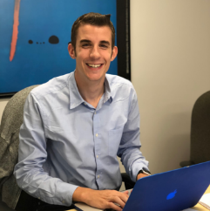
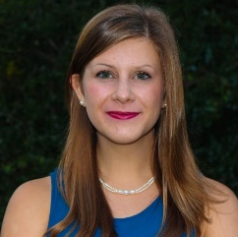
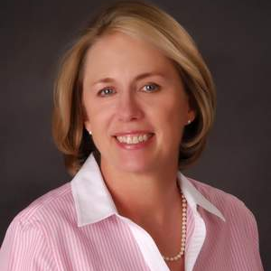
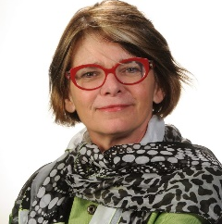
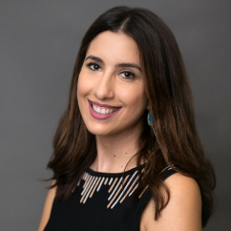
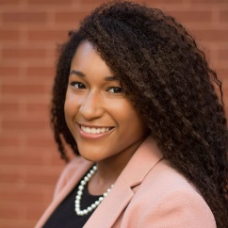
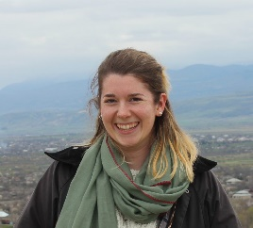
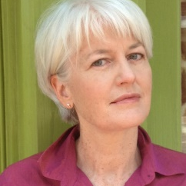
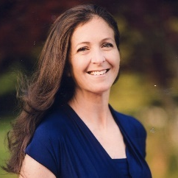
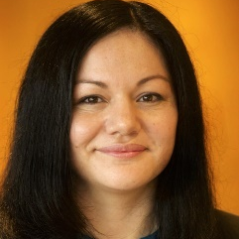
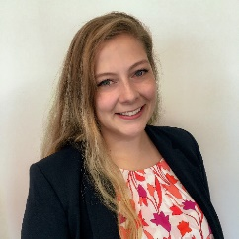
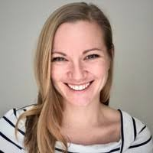

,

First row: Chantal de Jonge Oudraat, Ellen Haring, Antonieta Rico, Jeanette Gaudry Haynie, Karin Johnston, Nadia Crevecoeur, Beatriz Carboni
Second row: Diana Peiffer, Madeline Purkerson, Gina Taddeo, Soraya Kamali-Nafar, Hannah Lynch, John Arnold, Sarah Kenny
