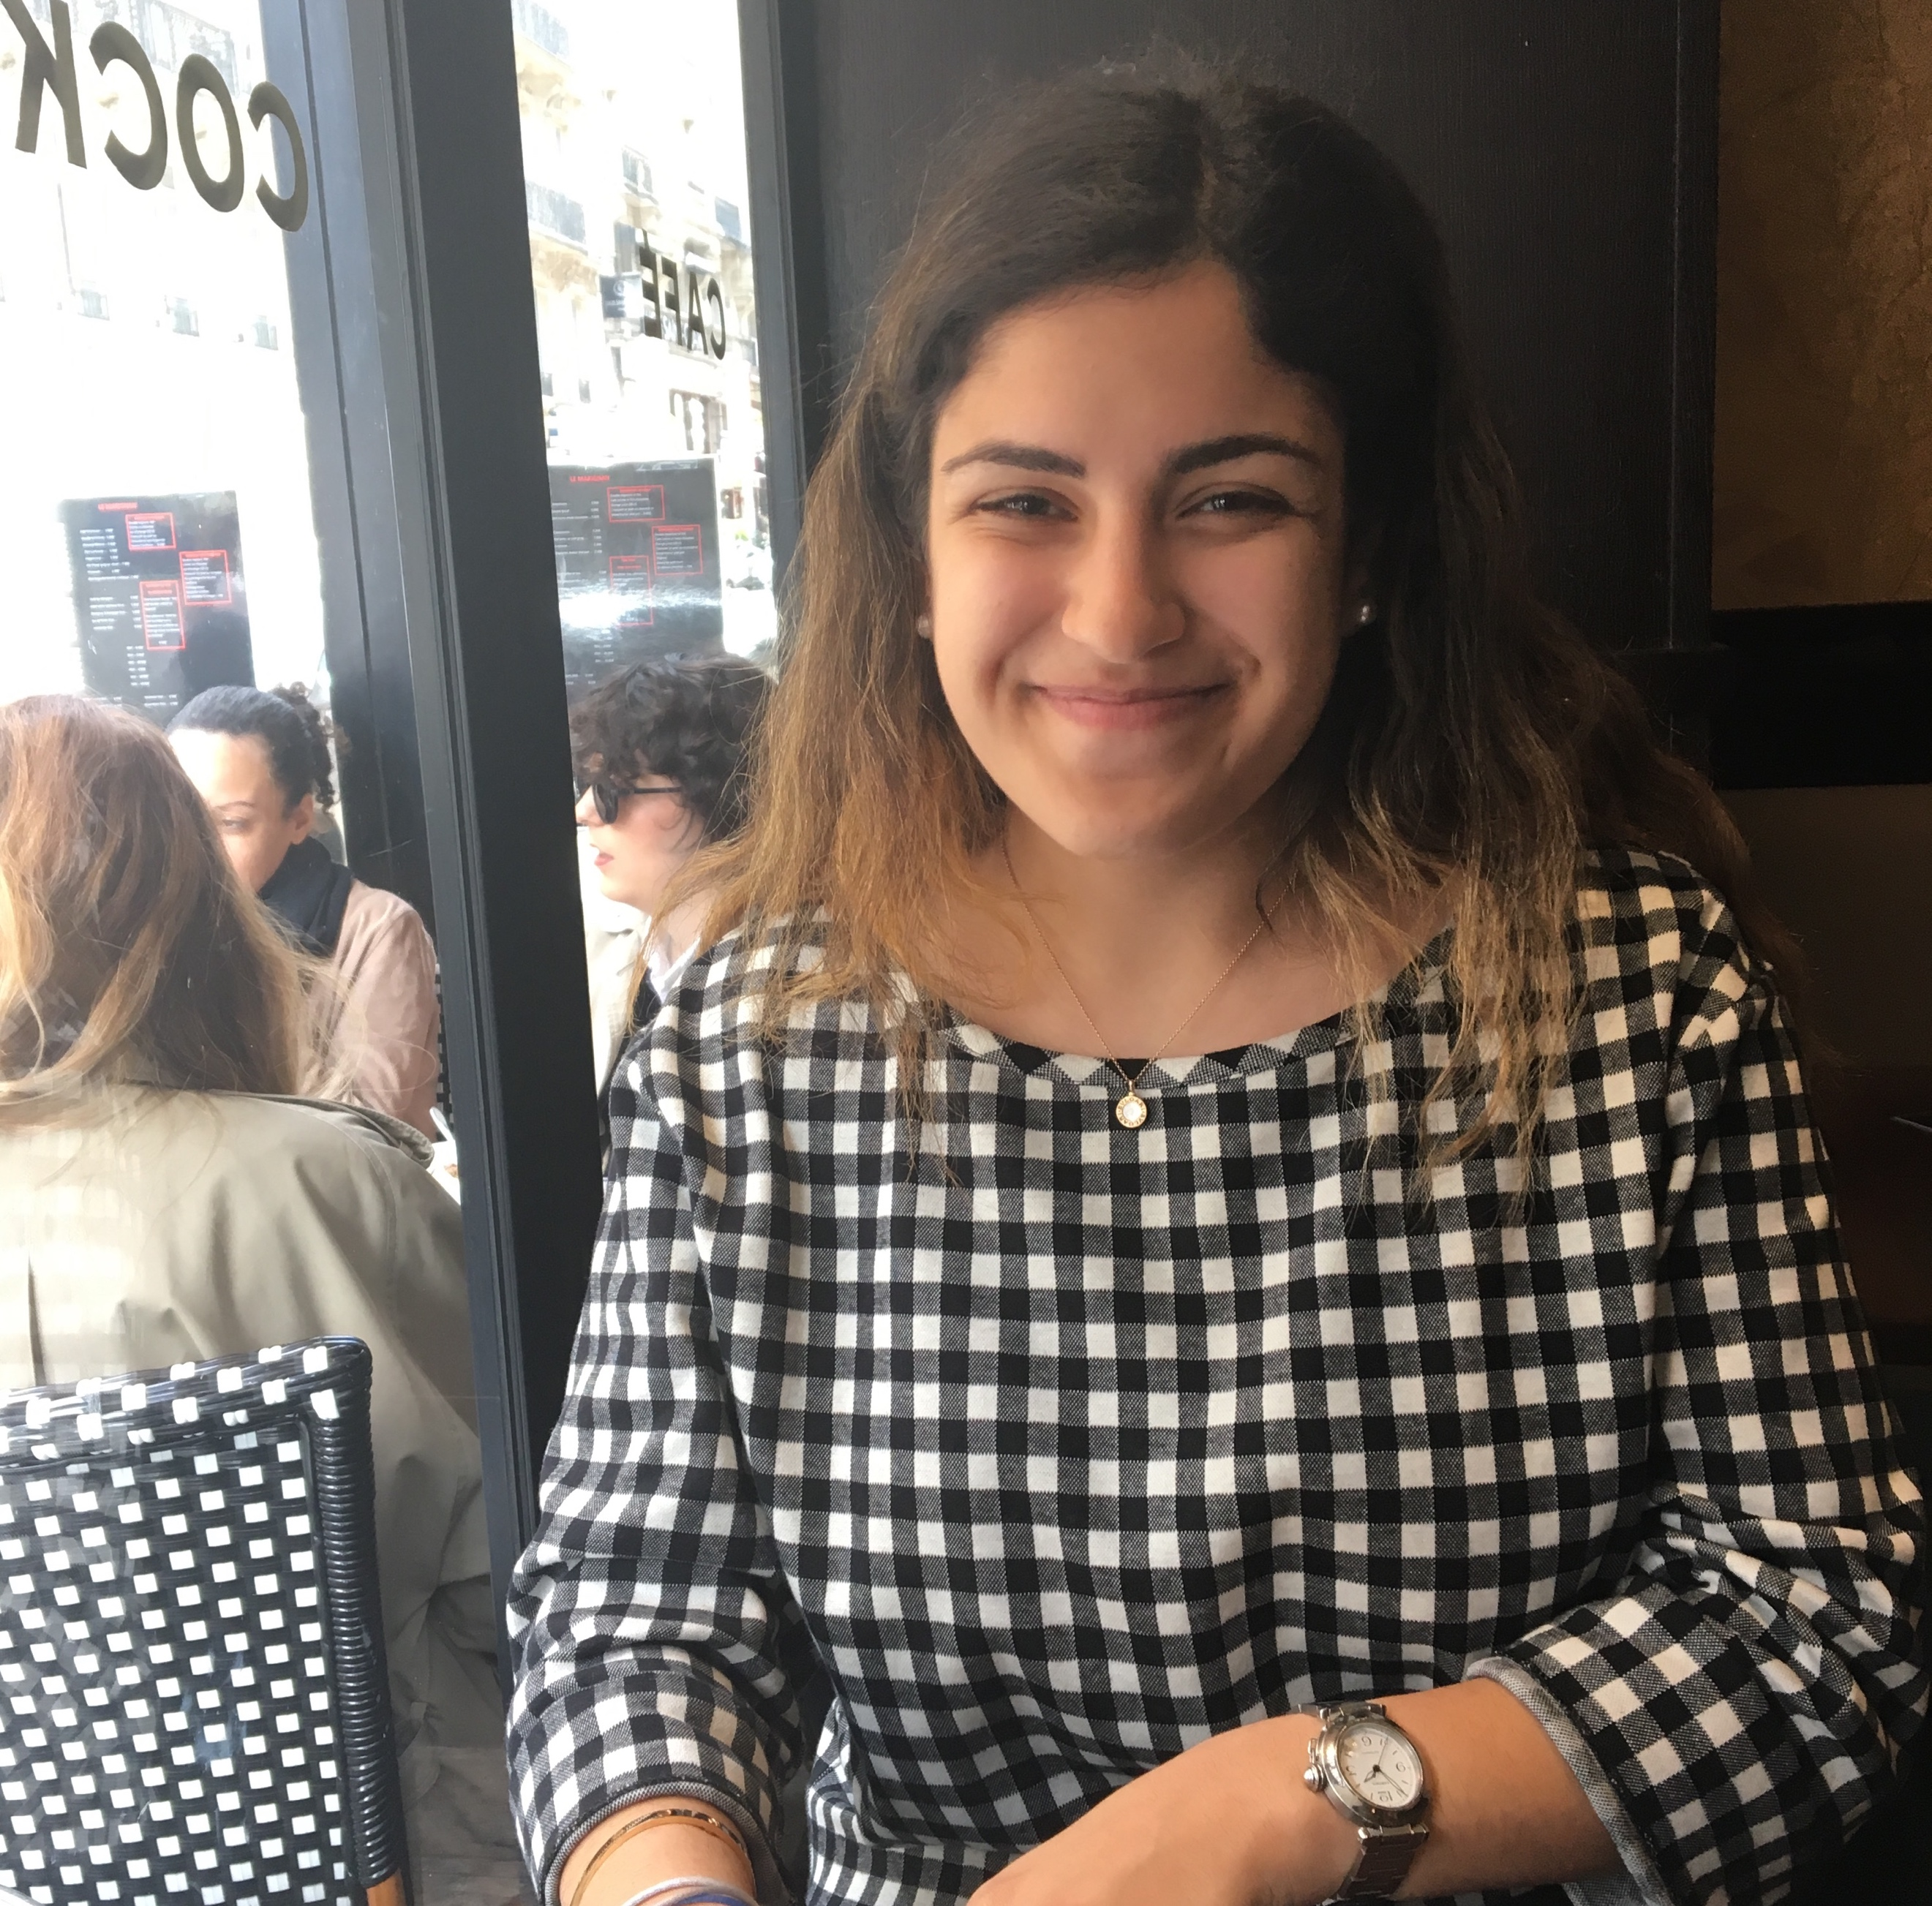
Soraya Kamali-Nafar

Program Assistant, sorayakn15@gmail.com
Soraya Kamali-Nafar is a Program Assistant at Women In International Security (WIIS). She is currently pursuing a BA in International Relations at the University of St. Andrews. Soraya has previously worked for the Office of the Attorney General for the District of Columbia, in the Public Advocacy division. Her research interests include human rights, gender-based violence, and international law.

